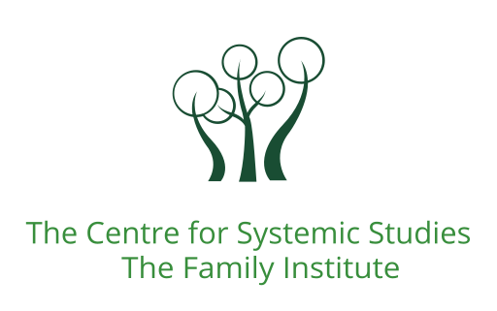
The Centre for Systemic Studies

Application Form

Course details
Name of the course applying for and year:

Applicant Details
Surname: |  | First Name:
Address:
Telephone No: |  | Email:

Previous Practice
What kind of practice are you currently involved in? (Systemic, Mental Health Nursing, Solution Focused, Social Work, etc) Please provide a brief description:
Where do you currently practice (if applicable)?
State the (approximate) number of hours of face to face practice with individuals, couples or families over the last 2 years. If working as part of a team, please also give details here:
If not currently in practice, please state the number of hours practice you hope to achieve following this course:
If not currently qualified, do you intend to pursue qualifying training?
Please detail any other relevant practice here (please continue on another sheet if necessary):

Professional Qualifications and Training
Please provide details of core training, post qualifying training and/ or relevant systemic, psychotherapeutic or family training that you draw upon in your practice.

Other training and details of any relevant Full Time, Part Time, Short Courses, Workshops, CPD etc. over the last 2 years.
MEMBERSHIP OF PROFESSIONAL ASSOCIATIONS
Membership Body | Membership Type | Date From | Date To

Other relevant information in support of your application.
This is an opportunity to introduce yourself- your practices, ethics, motivations and values. Include here what draws you to apply for the course, how you might incorporate your learning into your practice and any practice or life experience that feels relevant to draw our attention to, in support of your application.

Payment of course fees:
Please give name and full address of the payee:
The centre will invoice the payee for the amount. Should you wish to organise a payment plan please contact the Directors for The Centre for Systemic Studies.

Signed: |  | Date:
Print Name:
Please return your completed application form to NatalieWilliams@centreforsystemicstudies.co.uk
Thank you for your application and for providing us with information to help us review your application. This will be shared with the relevant course tutors for review. We will be in touch in due course.

